This is a Low poly Boat yard

With one texture and one material for all.

In this package

-1 House.

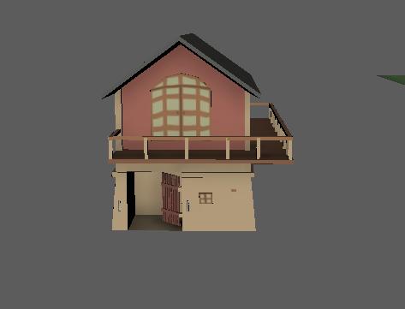

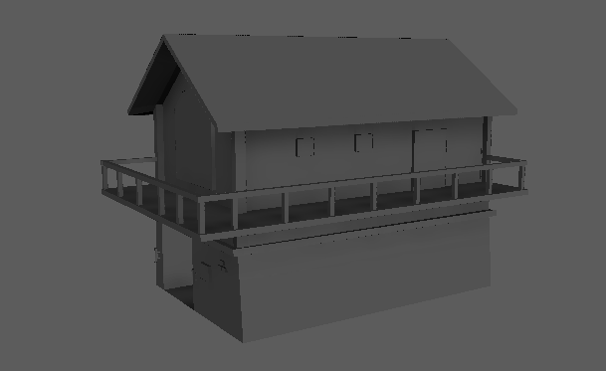

-2 Boats.

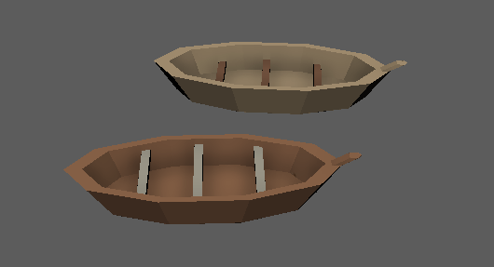

-3 Boat paddles.

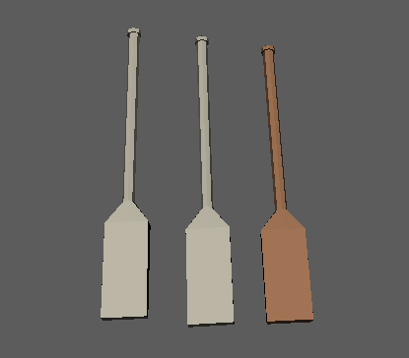

-2 Buckets.

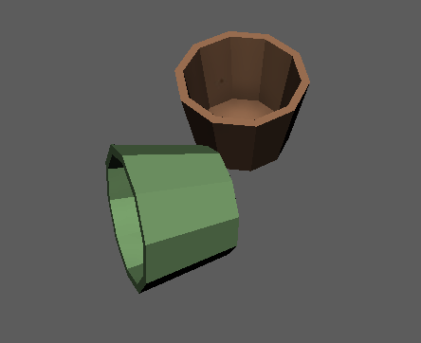

-1 wall.

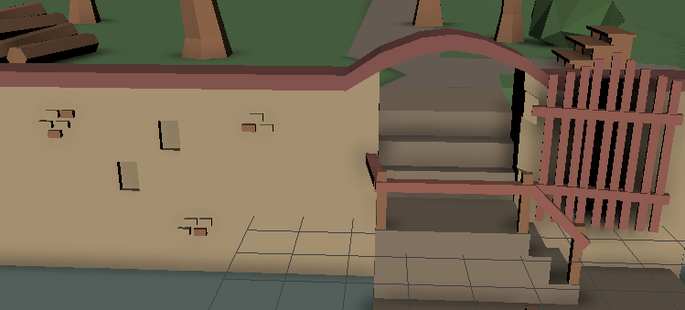

-14 trees.

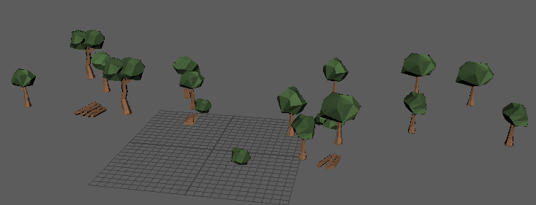

-1 texture (2048 x 2048 px).

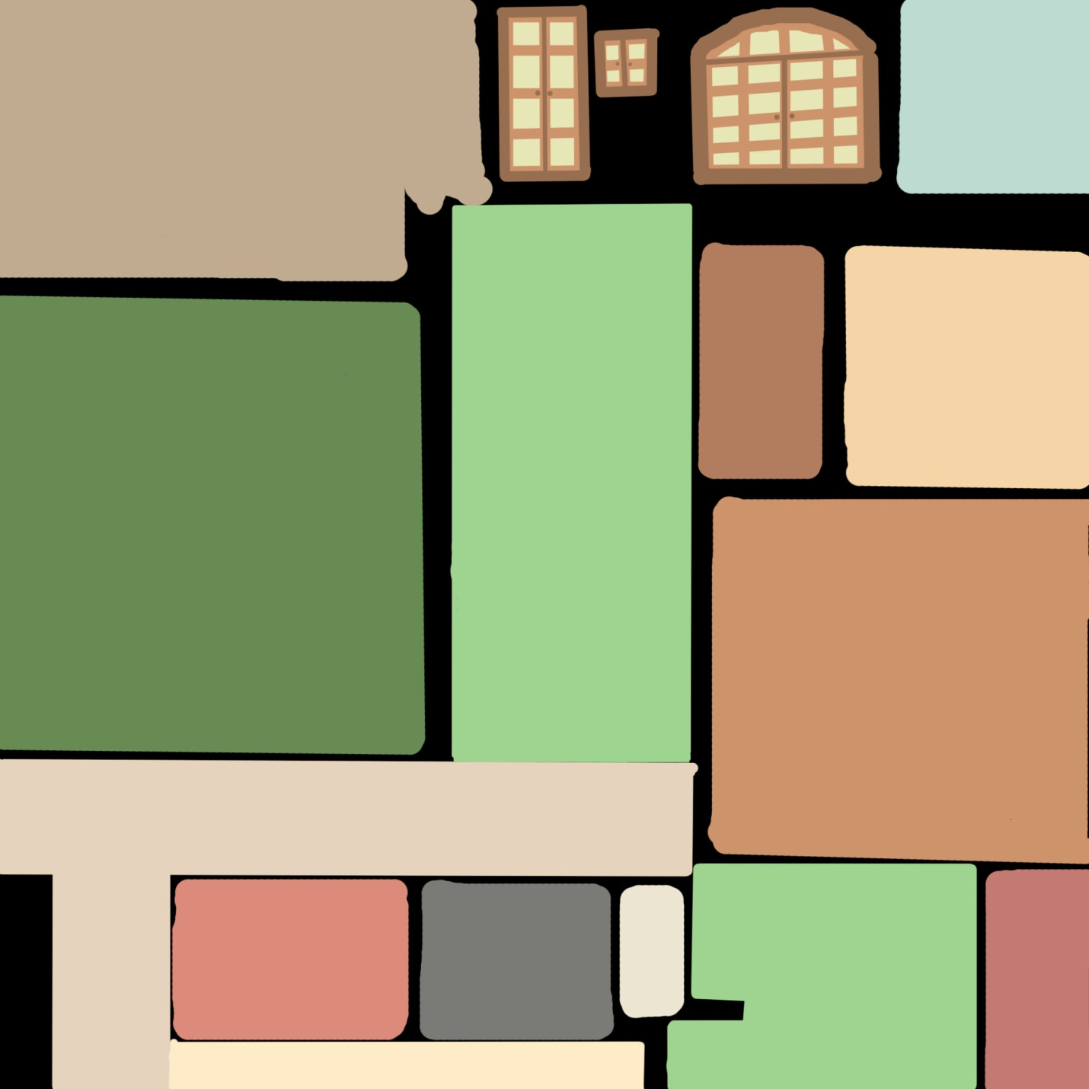

Please rate and comment our work. Let me know if something is wrong or needs to be

Improved

Abhishekshindekar@gmai.com